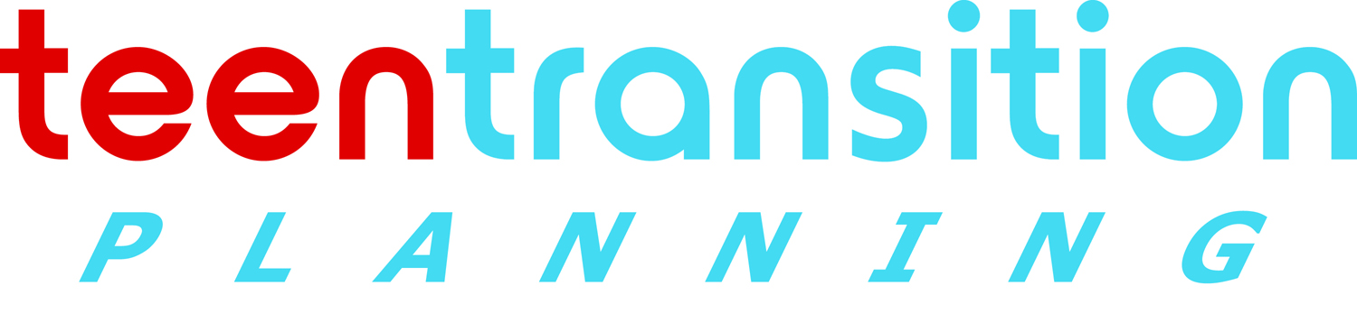 www.teentransitionplanning.ca
Take 5 for 4
Improving your facilitation skills is a process of continual learning. Make a habit of stopping to reflect after each meeting
What Went OK?  1 | What could be better next time?  ]  2
What will I do today to improve my effectiveness next time 4 | 3 What will I try doing next time?

