**TABLE 3: GETTING READY FOR THE NORTH STAR**

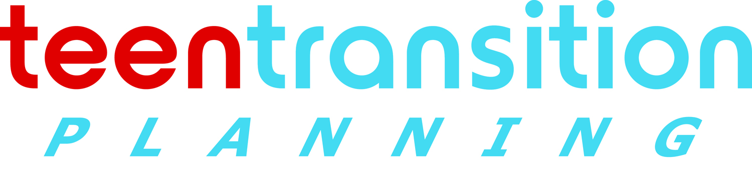 www.teentransitionplanning.ca

Life Skills & Adaptive Skills

Education

Health

Leisure, Culture and Spiritual

Family and Friends

Housing

Employment