SUMMARY OF PATH GOALS and PLAN and PREPARE TASKS

This checklist includes both the goals from your teen’s PATH and some “Plan and Prepare” tasks that support your teen’s transition. These may or may not be included in your individual Transition Plan but they can often help make the transition to adulthood easier. The Plan and Prepare goals are based on the Cross Ministry Transition Planning Protocol.


Transfer goals from the PATH to this section to summarize this year’s needs!

TASK CHECKLIST AGE 14-15 (Grade 9 & 10) | Person Responsible | Due Date | Check When  Completed
PATH GOALS

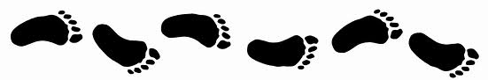

CHECKLIST AGE 14-15 (Grade 9 & 10) | Person Responsible | Due Date | Check When  Completed
FIRST STEPS

TASK CHECKLIST AGE 14-15 (Grade 9 & 10) | Person Responsible | Due Date | Check When  Completed
PLAN & PREPARE
Apply for a Social Insurance Number:
(http://www1.servicecanada.gc.ca/en/cs/sin/0200/0200_010.shtml)
Obtain a birth certificate
Participate in the school-directed Grade 10 Planning course to learn about planning for education and career transitions, financial planning, and decision -making skills.
Work with your family to make a long-term financial plan that will help you transition to adulthood.
Obtain copies of assessments for CLBC eligibility to have assessment done.

Transfer goals from the PATH to this section to summarize this year’s needs!

TASK CHECKLIST AGE 16-17 (Grade 11 & 12) | Person Responsible |  | Due Date | Check When  Completed
PATH GOALS

CHECKLIST AGE 16-17 (Grade 11 & 12) | Person Responsible |  | Due Date | Check When  Completed
FIRST STEPS

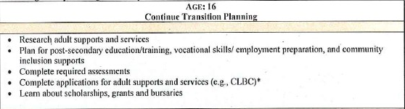

TASK CHECKLIST AGE 16-17 (Grade 11 & 12) | Person Responsible | Due Date | Check When  Completed
PLAN & PREPARE
6 Months before you turn 18 years old… apply for your Person with
Disability Benefits (PWD)?
NOTE: If you’re currently receiving ‘At Home Medical Benefits’ and you’re applying
for PWD: upon initial phone call to the Ministry of Housing & Social Development
Office (MHSD), inform the worker of this. Discuss the process of applying for
medical supplies with the worker at MHSD.
Make arrangements to visit agencies in your community that can offer day program opportunities, supported employment or volunteer opportunities.
Open a bank account, if you haven't already done so and obtain an ATM card.
Apply for a British Columbia Identification Card (B.C. I.D. Card).
www.icbc.com/licensing/lic_utility_id_cardPU.asp
Complete assessments for eligibility for CLBC Services and apply for services.

Transfer goals from the PATH to this section to summarize this year’s needs!

TASK CHECKLIST AGE 18 & 19 | Person Responsible | Due Date | Check When  Completed
PATH GOALS
CHECKLIST AGE 18 & 19 | Person Responsible | Due Date | Check When  Completed
FIRST STEPS

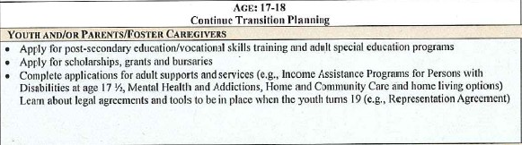

TASK CHECKLIST AGE 18 & 19 | Person Responsible | Due Date | Check When  Completed
PREPARE AND PLAN
With your family and school, determine whether or not you are eligible to attend an additional year of school.
If you are eligible for the CLBC Adult Community Living Services take your transition plan to the CLBC office and request the assistance of a Coordinator to review your plan which will then be submitted to the Quality Service Office to determine if requested CLBC funded supports are approved.
Establish strong connections in your community by volunteering and by exploring recreational, social and cultural opportunities.
Complete a personal portfolio of work and volunteer experience, such as your Graduation Transitions.
Ask your family, your lawyer, financial planner and/or transition coordinator to help you understand adult guardianship and will and estate planning.
For youth who will not be actively participating or directing their health care and other life decisions, consider preparing a Representation Agreement for when the youth turns 19 years of age).

